Mobile Email Client

📱 What Is a Mobile Email Client?
# Source: Chatgpt (GPT-5-Mini) at [1/21/2026]
A mobile email client is an app installed on a smartphone or tablet that allows you to send, receive, and manage emails on the go.
It’s the mobile version of a desktop email client or webmail, designed for touchscreens, smaller screens, and on-demand access.

🧰 Examples of Mobile Email Clients
# Source: Chatgpt (GPT-5-Mini) at [1/21/2026]
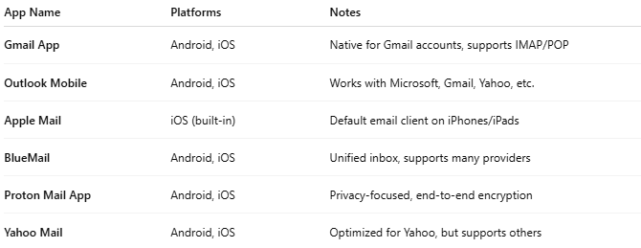

App Name | Platforms | Notes
Gmail App | Android, iOS | Native for Gmail accounts, supports IMAP/POP
Outlook Mobile | Android, iOS | Works with Microsoft, Gmail, Yahoo, etc.
Apple Mail | iOS (built-in) | Default email client on iPhones/iPads
BlueMail | Android, iOS | Unified inbox, supports many providers
Proton Mail App | Android, iOS | Privacy-focused, end-to-end encryption
Yahoo Mail | Android, iOS | Optimized for Yahoo, but supports others

📦 What Does a Mobile Email Client Do?
# Source: Chatgpt (GPT-5-Mini) at [1/21/2026]
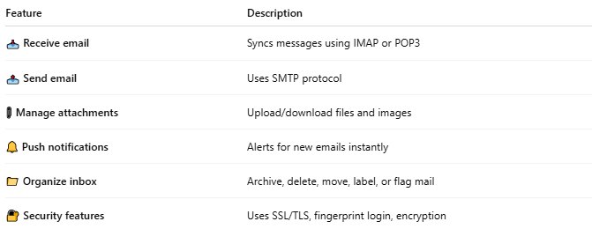

Feature | Description
📥 Receive email | Syncs messages using IMAP or POP3
📤 Send email | Uses SMTP protocol
📎 Manage attachments | Upload/download files and images
🔔 Push notifications | Alerts for new emails instantly
📁 Organize inbox | Archive, delete, move, label, or flag mail
🔐 Security features | Uses SSL/TLS, fingerprint login, encryption

🧠 How It Works
# Source: Chatgpt (GPT-5-Mini) at [1/21/2026]
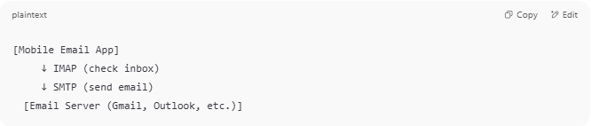

[Mobile Email App]
↓ IMAP (check inbox)
↓ SMTP (send email)
[Email Server (Gmail, Outlook, etc.)]

🔁 Compared to Other Clients
# Source: Chatgpt (GPT-5-Mini) at [1/21/2026]
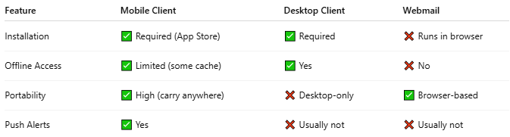

Feature | Mobile Client | Desktop Client | Webmail
Installation | ✅ Required (App Store) | ✅ Required | ❌ Runs in browser
Offline Access | ✅ Limited (some cache) | ✅ Yes | ❌ No
Portability | ✅ High (carry anywhere) | ❌ Desktop-only | ✅ Browser-based
Push Alerts | ✅ Yes | ❌ Usually not | ❌ Usually not

✅ Summary
# Source: Chatgpt (GPT-5-Mini) at [1/21/2026]
A mobile email client is an email app for smartphones or tablets that helps you manage your inbox wherever you are.
It connects to email servers using IMAP and SMTP, offers real-time notifications, and often includes file support, calendar, and security features.

